EmpowerNET Installation Instructions
Installation Files 3
Server Microsoft .NET Framework 4.8.1 3
Active Directory User and Group Setup on the Server 3
User and Group Setup for Active Directory 4
Create Empower Users Group 4
Create EmpowerSupport Service User 4
Log on as Service Policy 5
Non-Domain Controller 5
Domain Controller 5
Server Microsoft SQL Server Installation 6
Enable TCP/IP and Named Pipes Network Protocol 6
Create Empower Database 6
Create Empower Users Login 7
EmpowerSupport Setup 8
Download EmpowerSupport 8
Uninstall EmpowerSupport 8
Install EmpowerSupport 9
Troubleshooting EmpowerSupport Installation 10
Run EmpowerSupport Application 11
Settings - Database Connections 11
Settings – Active Directory 13
Settings – Locations 14
Upgrade Databases 15
Install to Computers 16
Firewall Setup 17
Group Policy Firewall Setup (Workstation Firewall Exceptions) 17
Workstation Manual Firewall Setup 17
Workstation 3rd Party Firewall Setup 18
Database Server Firewall Setup 19
EmpowerSupport Server Firewall Setup 20
Troubleshooting 22
The RPC server is unavailable 22

Installation Files
The EmpowerNET family of applications is installed on a single server and multiple clients.
Server | Client
Microsoft .NET Framework 4.8.1  Microsoft SQL Server 2016 or greater  EmpowerSupport | Empower Prerequisites  EmpowerWin
The installation files for the .NET Framework and Microsoft SQL Server are available from the Microsoft website
The download for the installation file for EmpowerSupport is sent to you via an email by Empower Financials
Once installed, EmpowerSupport will be used to download the Empower Prerequisites and EmpowerWin installation files.

Server Microsoft .NET Framework 4.8.1
The Microsoft .NET Framework 4.8.0 or higher is required to run the EmpowerNet family of products. The server must have an installation of the Microsoft .NET Framework 4.8.0 or higher before any other installations are done. The installation of Microsoft .NET Framework 4.8.1 or higher is required on any computer running the EmpowerWin application.

Active Directory User and Group Setup on the Server
Empower uses an Active Directory Empower Users group for giving users access to the Empower database.
Empower also uses a svc_empowersupport user account for running the EmpowerSupport service.

User and Group Setup for Active Directory

Create Empower Users Group
- Open Start Administrative Tools Active Directory Users & Computers
- Right click the correct OU and click New Group.
  - NOTE: Some sites will have organization unit’s setup in their Active Directory to store users and groups. If OU’s have been setup, find the appropriate OU for Groups; otherwise, use the default Users object.
- Type Empower Users for the group name.
- Click Create.

Create EmpowerSupport Service User
- Open Start Administrative Tools Active Directory Users & Computers
- Right click the correct organizational unit (OU) and click New User.
  - NOTE: Some sites will have OU’s setup in their Active Directory to store users and groups. If OU’s have been setup, find the appropriate OU for Users; otherwise, use the default Users object.
- Type svc_empowersupport for the username.
- Type a password and confirm password.
- Uncheck User must change password at next logon.
- Check Password never expires.
- Click Create.
- Double click svc_empowersupport.
- Select the Member of Tab and click Add.
- Type Domain Admins; Empower Users;
- Click OK.

Log on as Service Policy

Non-Domain Controller
- Open Control Panel Administrative Tools Local Security Policy
- Expand Local Policies User Rights Assignment
- Open the Log on as a service policy and click Add User or Group
- Type svc_empowersupport
- Click OK

Domain Controller
- Open Control Panel Administrative Tools Group Policy Management
- Select Domains Domain Domain Controllers
- Select Properties/Group Policy tab
- Right click Default Domain Controllers Policy and click Edit
- Expand Computer Configuration Windows System Security
- Select Local Policy/ User Rights
- Open the “Log on as a service” policy and click Add User or Group
- Type svc_empowersupport
- Click OK

Server Microsoft SQL Server Installation
After the Microsoft .NET Framework 4.x is installed the installer either verifies that a supported version of Microsoft SQL Server is installed (version 2016 or higher) or installs Microsoft SQL Server Express. You can download Microsoft SQL Server Express from the Microsoft website.
After you install Microsoft SQL Server Express you need to enable the Named Pipes and TCP/IP Network protocol.

Enable TCP/IP and Named Pipes Network Protocol
- Open All Programs Microsoft SQL Server 2016 Configuration Tools SQL Server Configuration Manager.
- Open up the trees on the left side panel until you find one for Client Protocols.
- Set the Named Pipes and TCP/IP protocols to enabled.
- Exit the Configuration Manager and then use Services under Administrative Tools to Stop and Start service for the database engine.

Create Empower Database
- Open SQL Server Management Studio.
- Connect to the instance you created when installing SQL Server.
- Right click on Databases and click New Database.
- Type Empower for the database name.
- Change the initial size of the Empower file to 100MB and change the auto growth to 10MB.
- Change the initial size of the Empower log file to 10MB.
- Click OK.

Create Empower Users Login
- Open SQL Server Management Studio.
- Connect to the instance you created when installing SQL Server.
- Expand Security Logins.
- Right click on logins and click New Login.
- Click Search.
- Change the selected object types to include Groups.
- Change the Location to Entire Directory.
- Type Empower Users.
- Click OK.
- Change the default database to Empower.
- Select the User Mapping tab.
- Map Empower.
- Select db_owner and public under database role membership.
- Click OK.

EmpowerSupport Setup
Empower Financials delivers installation files, and any related files, to you through our EmpowerSupport application. This application will help you download and deploy updates to computers on your network. EmpowerSupport consists of the EmpowerSupport application (executable) and the Empower Support service.

Download EmpowerSupport
Contact Empower Financials and request an email be sent to enable you to download the EmpowerSupport installation files from our FTP site.
Click the link in the email. You are taken to our FTP site and shown the files.
Click on the download icon in the upper right on the screen.
A zip file containing the EmpowerSupport installation files is sent to your Downloads folder.
Extract the Zip file contents into a folder. We recommend c:\EmpowerUpdates, however you may use any folder you like.

Uninstall EmpowerSupport
If you have previously installed the EmpowerSupport application, you should uninstall the app before running the EmpowerSupport.msi file to install a new release.
- Run the Windows Add and Remove Programs.
- Scroll down to EmpowerSupport and click the Uninstall option from the ellipsis control

Install EmpowerSupport
- Navigate to the folder containing the extracted files. Click on EmpowerSupport.msi
- When the installation begins a welcome screen is displayed.
- On the welcome screen click Next.
- On the destination folder screen click Next.
If you prefer, you can change the location where EmpowerSupport will be installed (not recommended).
- Click Install.
- After EmpowerSupport is installed you will want to change the Empower Support service account information.
- Run Windows Services. Select the Empower Support service and Stop the service.
- Right click, select Properties.
- On the General tab, set Startup type to “Automatic (Delayed Start)”.
- Click on the Log on tab.
- Change the Account to use “svc_empowersupport” (or the account you have created for the Empower Support Service in a previous step in these instructions). Enter the password for svc_empowersupport.
- Click OK. Exit the Properties window.
- Start the EmpowerSupport Service
You may now run the EmpowerSupport app from the Windows Start button.

Troubleshooting EmpowerSupport Installation
If EmpowerSupport does not start, or starts and then quits, double-check the following:
Run Active Directory. Check the svc_empowersupport account is a member of the Empower Users group in Active Directory
In SQL Server Management Studio, navigate to Security, Logins and click on the Empower Users group. Right click Properties. In the Properties window click on User Mappings in the left-hand panel. Click on your database. In the Users mapped to section click on your database checkbox to select it. Check in the Database Role Membership tile at the bottom of the page that db_owner is checked and public is checked. Exit SSMS.
Run Services from the Windows Start button. Navigate to the Empower Support service. Highlight it and right click to Restart the service.

Run EmpowerSupport Application
You can run the EmpowerSupport application from Start Menu All Programs EmpowerNet EmpowerSupport. EmpowerSupport must be run with administrator privileges. If you are prompted to allow the application to run as an administrator, click yes.

Settings - Database Connections
The first time you run EmpowerSupport you will need to enter your database connection information under “Settings – Database Connections.” The database connection information is stored in an empower.config file which is deployed with EmpowerWin and is used to connect EmpowerSupport and EmpowerWin to the database(s) specified.
- If your Empower users will connect to the database(s) with SQL Server Authentication, check the “Encrypt Connections” checkbox so that the SQL Server user ID and password are encrypted in the empower.config file.
- Click the Add button to add a database connection
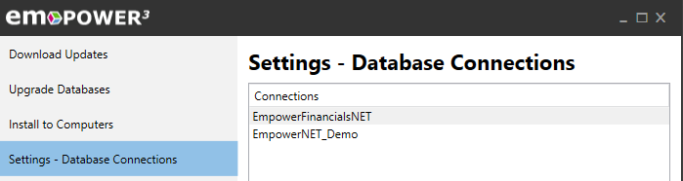
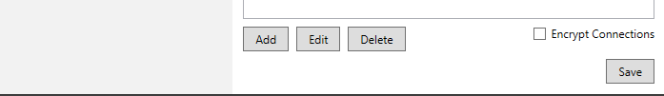

When you click Add, Empower opens a new window with a database connection Name of Empower. This is a “user friendly” name that the users see when they log into EmpowerWin. You can change the name if you have multiple databases. For example, you might have one database called “Empower” and another called “Empower Test.”
Populate the remaining information and click OK to be returned to list of database connections.
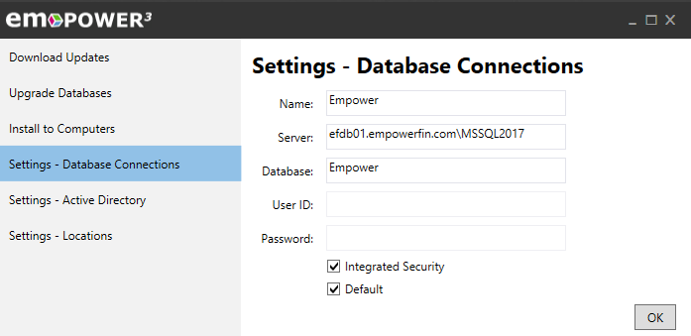
After you set up one or more database connections click Save in the lower right.
At this point you should restart the EmpowerSupport service under Administrative Tools > Services.
You can edit the database connections at any time by clicking on the “Settings – Database Connections” tab, highlighting a database, and clicking the Edit button.

Settings – Active Directory
If you want to use Active Directory to validate your users’ Empower passwords, the first time you run EmpowerSupport you will need to enter your LDAP path under “Settings – Active Directory.” Be sure to capitalize the word LDAP. After entering the path, click Save in the lower right.
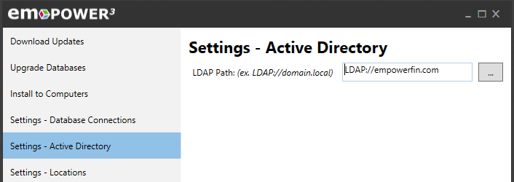

Settings – Locations
Under “Settings – Locations” you tell Empower
- The Backup Folder used to hold the database backup created prior to installing a new Empower version. Make sure SQL Server can write to this folder.
- The Updates Folder into which EmpowerSupport should download EmpowerWin updates.
- The URL for the Windows Installer service. Click the ellipsis button to the right of the Update Installer URL to populate this value. When you click Save, this value is written into the Default database defined under “Settings – Database Connections.” If you have multiple databases, please contact Empower for help to populate this value in each of your databases.
After entering the Locations, click Save in the lower right.
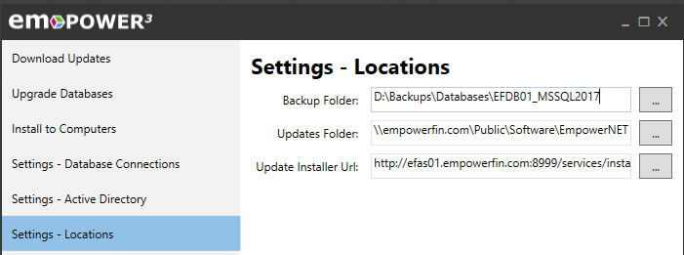

Upgrade Databases
- Select the database you want to upgrade
- Select the version you want to upgrade the database to. You will almost always be upgrading to the most recent version which will be the version shown by default.
- Click Backup.
- After backing up your database click Upgrade
If you prefer to run the scripts manually you can extract them to a file by clicking “Save to File.”
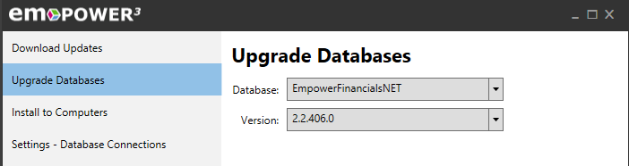
After the database has been upgraded any computer already running EmpowerWin will detect the new version and prompt the user to install the update. The user will not be able to log into that database until they have installed the new update.

Install to Computers
The Install to Computers tab allows you to deploy the EmpowerWin application or the Crystal Reports runtime to computers on your network.
- Type a computer name in the computer(s) text box or multiple computers separated by a semi-colon
- Select the version of EmpowerWin
- Click Install

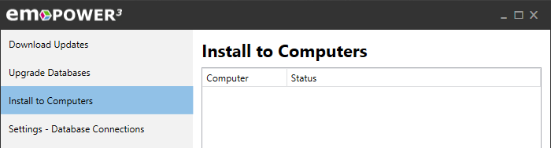

Firewall Setup
To use EmpowerSupport successfully you will need to add firewall exceptions to the servers and workstations on your network.
When running active directory use group policy to deploy workstation exceptions.

Group Policy Firewall Setup (Workstation Firewall Exceptions)
- On your Active Directory domain controller login with administrative privileges.
- Open Control Panel Administrative Tools Group Policy Management.
- Expand the Forest Domains
- Right Click on the domain and select “Create a GRO in this domain”
- Type EmpowerSupport Firewall Exceptions for the name of the policy
- Click OK.
- Right click on the new Policy that was created and select Edit.
- Expand Computer Configuration Policies Administrative Templates Network Network Connections Windows Firewall Domain Profile
- Double Click Windows Firewall: Allow remote administration exception.
- Click Enabled.
- Click OK.

Workstation Manual Firewall Setup
To manually enable Remote Administration on a workstation.
Go to the Group Policy Editor.
- Expand Computer Configuration Administrative Templates Network Network Connections Windows Defender Firewall Domain Profile
- Click on “Domain Profile”
- Double Click Windows Firewall: Allow remote administration exception.
- Click Enabled.
- Click OK.

Below is a way to create the rule using the Command Prompt run as Administrator, shown here for historical purposes.

- Open the command prompt from Start Menu All Programs Accessories.
If you are running Windows Vista or later with User Account Control turned on you must run the command prompt with administrative privileges, right click on Command Prompt and select Run as administrator.
- Type netsh firewall set service type = remoteadmin mode = enable
- Click Enter

Workstation 3rd Party Firewall Setup
- Open TCP ports 135 and 445
- Open WMI Fixed Port TCP 24158
- Change WMI on client computer to use Fixed Port
  - winmgmt –standalonehost
  - net stop winmgmt
  - net start winmgmt
- Allow SVCHOST.EXE and LSASS.EXE to receive unsolicited incoming messages

Database Server Firewall Setup
If you are running Windows Firewall on the database server you need to create an Inbound Rule to enable access to the SQL Server executable, and if using a named instance for the SQL Server Service, the SQL Server Browser executable.
From the Start menu, run the Windows Firewall and Advanced Security menu option.
- Left click on In Bound Rules to select, then right click and select New Rule.
Name the Rule SQL Server vvvv (version such as 2022) Executable
(at the end of the wizard).

Select Program, then when prompted enter the location of the exe you are creating the rule for.

You can use Windows explorer to find the Directories the files are stored in.

When you use a named instance of SQL Server 2022 the SQL Server executable name/location is in the folder:

C:\Program Files\Microsoft SQL Server\MSSQL16.SQLSERVER202208\MSSQL\Binn
Where the instance name is part of the MSSQL16.<instance name> folder
You need to make sure that you have the correct network type enabled for the inbound rule. After saving the rul click on it and select Properties. Then click on the advanced tab.
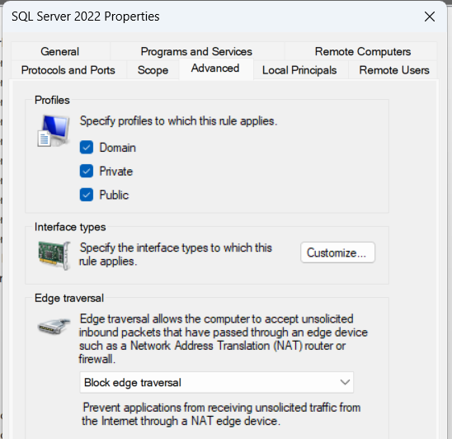
Click on all Policies: Domain, Public, Private.
Domain is self-explanatory
Public is used when your network is linked PCs on a wiFi network(Empowers)
Private I am not sure of, but check it.

- If using a named instance, you need to have started the SQL Service Browser Service on your DB server after installing SQL Server.

- Now you must create an InBound Rue to give access to that service to remote users.
- IN Firewall, click In Bound Rules in the Navigation Panel, then right click and select New Rule.
Name the Rule SQL Browser Executable

The name and location of the SQL Browser is:

C:\Program Files (x86)\Microsoft SQL Server\90\Shared\sqlbrowser.ext
Be sure to click on the Advanced tab and check all Policy Types: Domain,Public,Private.

EmpowerSupport Server Firewall Setup
You will also need to add an In Bound Rule for the EmpowerSupport Service on the server running Empower Support (which may be different from the database server):
From the Start menu, run the Windows Firewall and Advanced Security menu option.
Left click on In Bound Rules to select, then right click and select New Rule.

Click on the Protocols and Ports tab
Set Protocol Type to TCP
Select Specific Port and enter 8999.
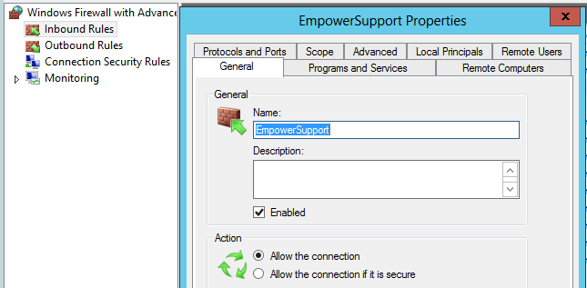
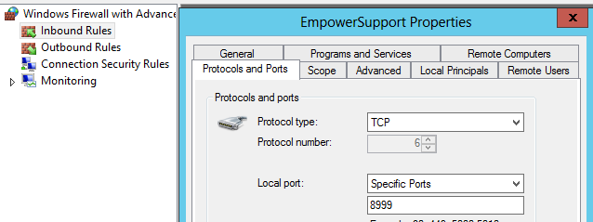

Below is a way to create the rule using the Command Prompt run as Administrator, shown here for historical purposes.)
- Open the command prompt from Start Menu All Programs Accessories.
If you are running with User Account Control turned on you must run the command prompt with administrative privileges, right click on Command Prompt and select Run as administrator.
- Type netsh advfirewall firewall add rule name="EmpowerSupport" dir=in action=allow protocol=TCP localport=8999
- Click Enter

Troubleshooting

The RPC server is unavailable
- The most common cause is the firewall ports have not been opened.
  - Try disabling the Firewall on the client computer, if this solves the problem then ensure you have followed the steps properly to enable the firewall exceptions (see Firewall Setup).
- Another cause can be that the client computer is not trusted on the domain.
  - This can happen if the client computer is not joined to the domain. If this is the case, you must join the client computer to the domain.
  - Another cause can be if the password for the client computer and the password for the computer account on the domain are out of sync. You can solve this by removing the computer from the domain and re-adding it to the domain (See http://support.microsoft.com/kb/216393).
- Verify that the service account that EmpowerSupport service is running under has domain admin rights.
  - Logon to the server that has EmpowerSupport installed as the service account.
  - Open Computer Management under Administrative Tools
  - Right click the computer Management node and select Connect to another computer
  - Type the client computer name
  - Click OK.
  - Until this allows you to manage your client computer, EmpowerSupport will not be able to connect and install the software on the client computer.
- Troubleshoot WMI on Local PC
  - Use wbemtest on local computer and connect to local computer
    - If this fails then repair WMI
- Repair WMI on Local PC
  - Disable and stop the Windows Management Instrumentation service.
  - Right-click Command Prompt and select Run as Administrator.
  - In the Command Prompt, type cd %windir%\system32\wbem and press Enter.
  - Type for /f %s in ('dir /b *.dll') do regsvr32 /s %s and press Enter to re-register WMI DLL files.
  - After completed, type for /f %s in ('dir /b *.mof') do mofcomp %s and press Enter to re-compile WMI mof files.
  - After that, type the command wmiprvse /regserver and press Enter.
  - Start the Windows Management Instrumentation service and change the Startup Type back to Automatic.

